BI REPORT APP CONNECTION

- Make a folder (crm-bi-report) on project directory.
- Clone crm-bi-report app into that folder.
Example shown below
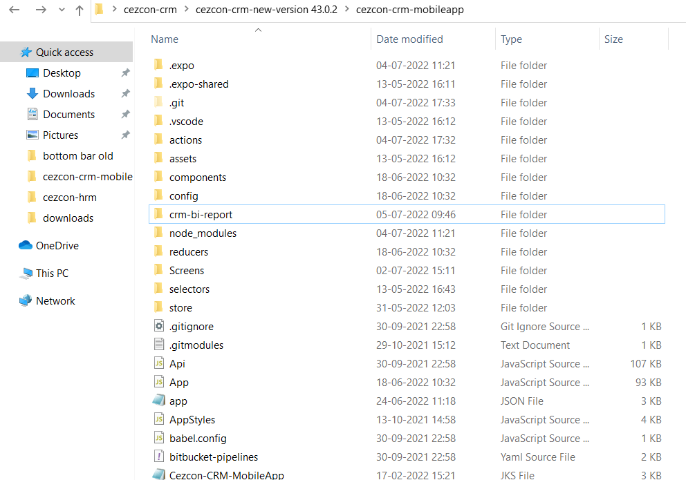

- Open crm App.js
- Uncomment the bi report import code.
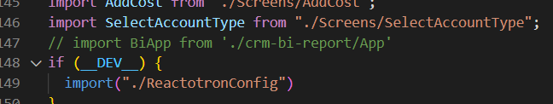
- Uncomment the useeffect code.
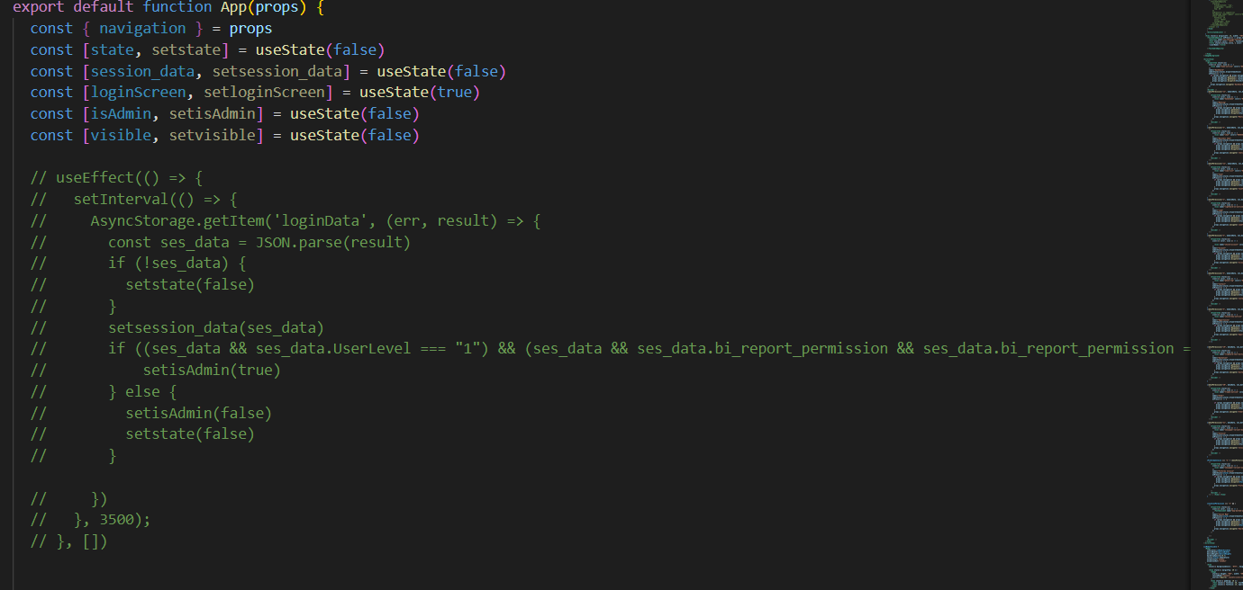
- Uncomment this selected code.
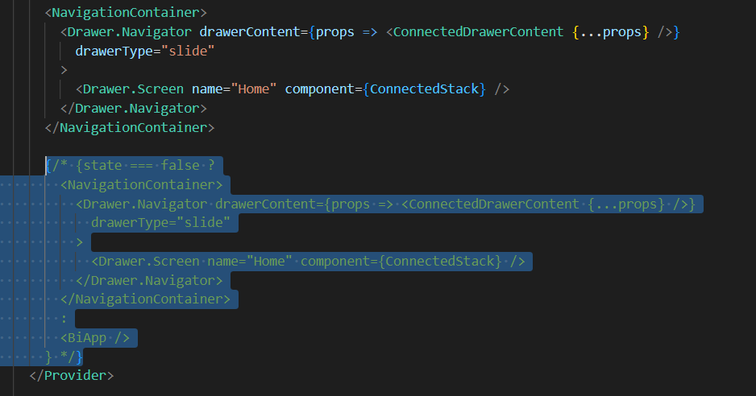

- Comment this selected code.
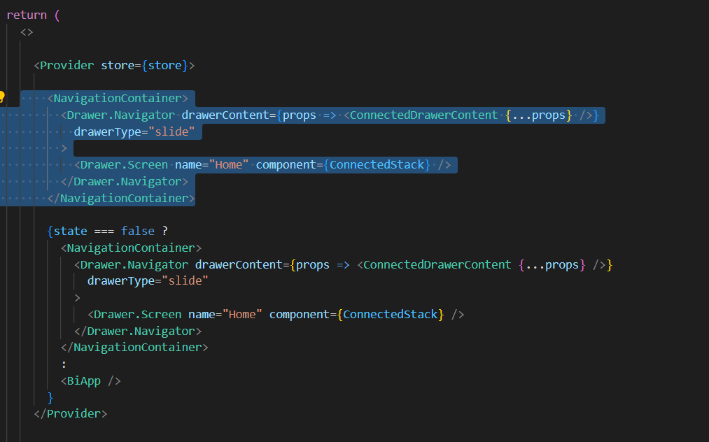

Uncomment this selected code.
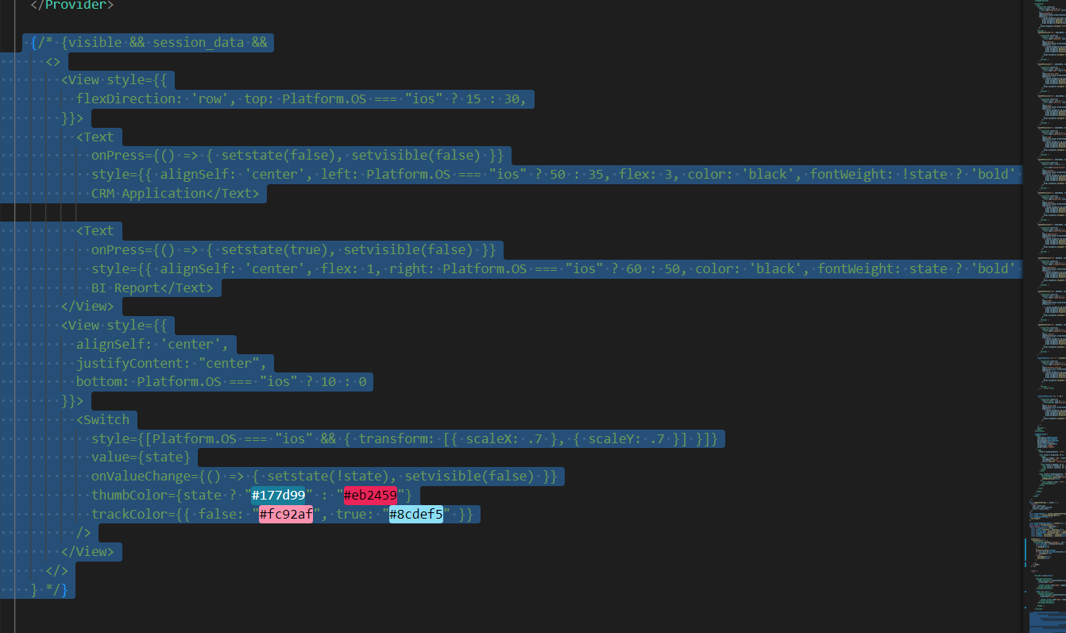
- Uncomment this selected code.
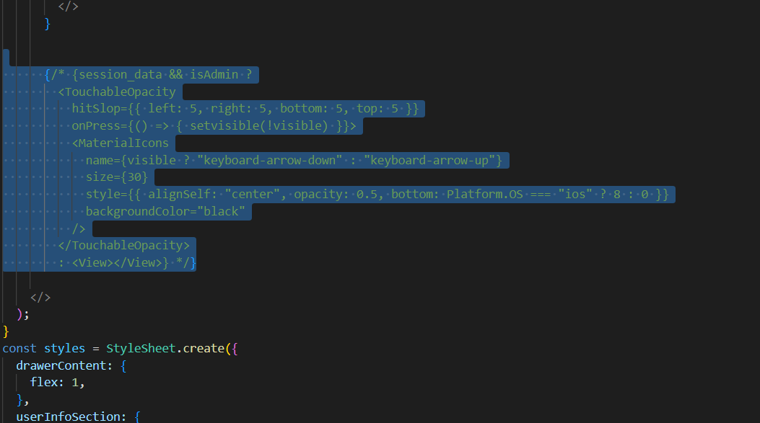

- Open crm-bi-report App.js
- Uncomment this selected code.
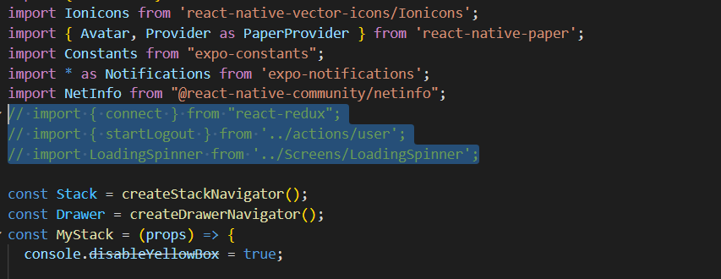
- Uncomment this selected code.
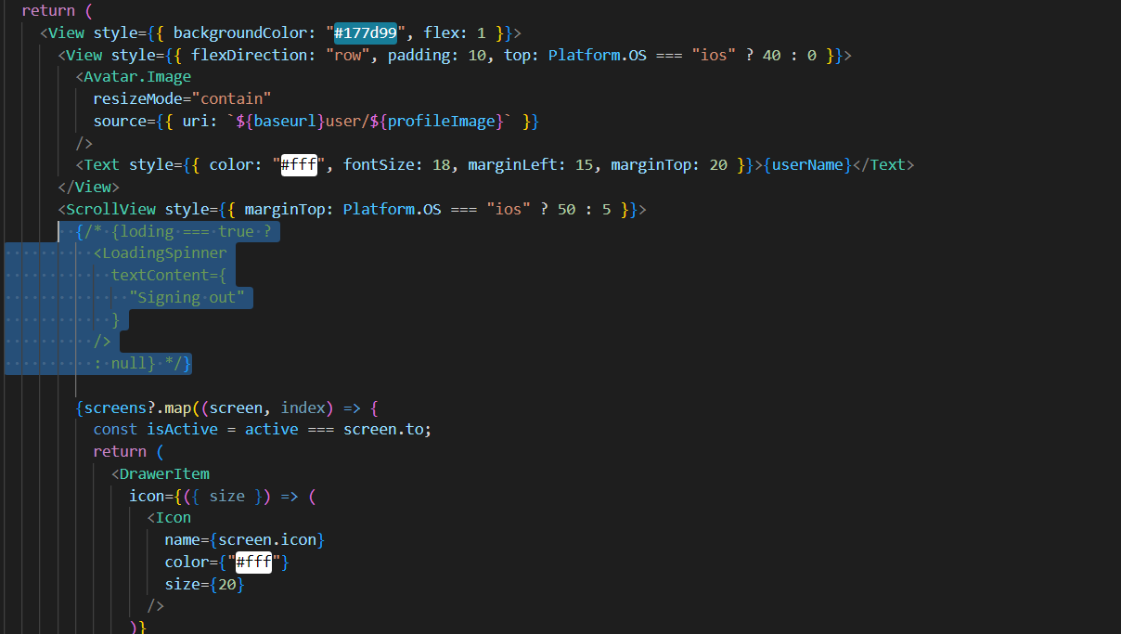

- Uncomment this selected code.
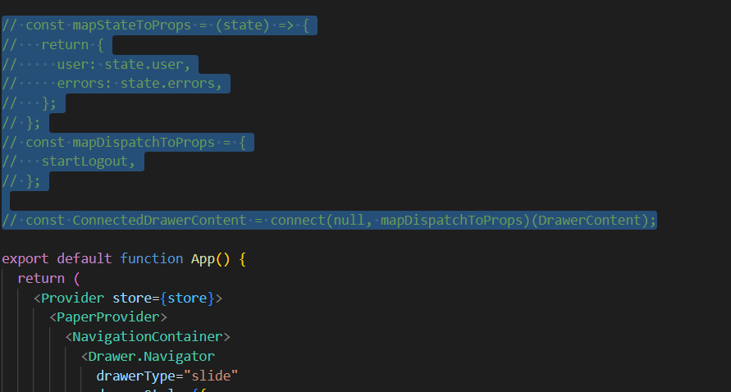
- Uncomment the commented drawerContent and comment the uncommented drawerContent.
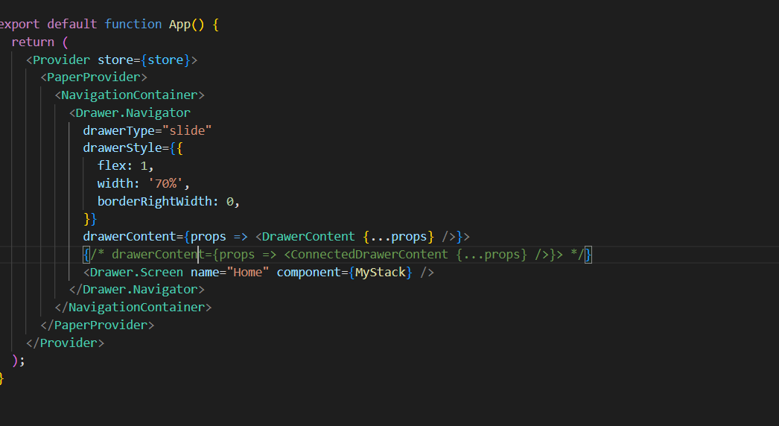

- Open crm-bi-report -> screens -> sales kpi
- Uncomment this selected code.
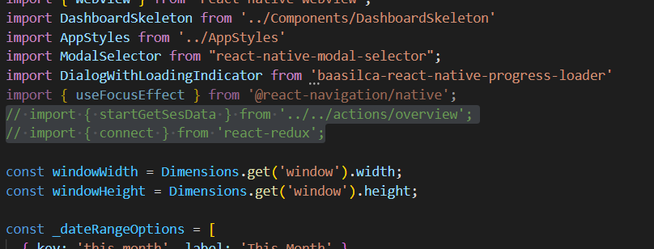
- Uncomment this selected code.
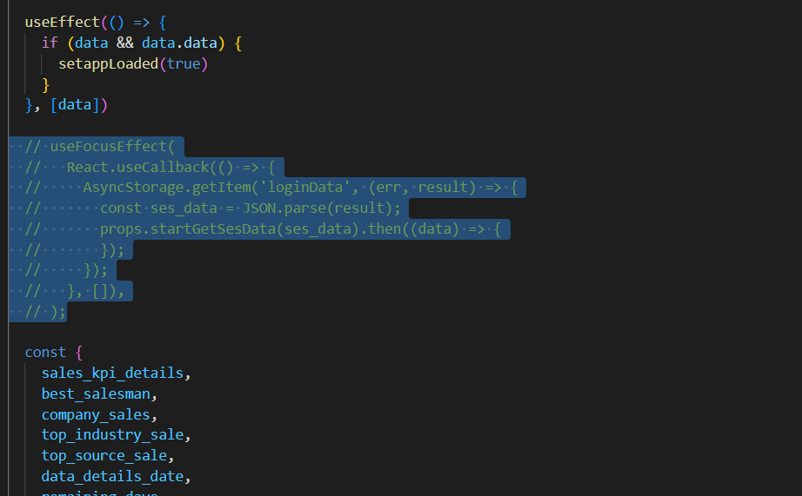

- Uncomment this selected code .
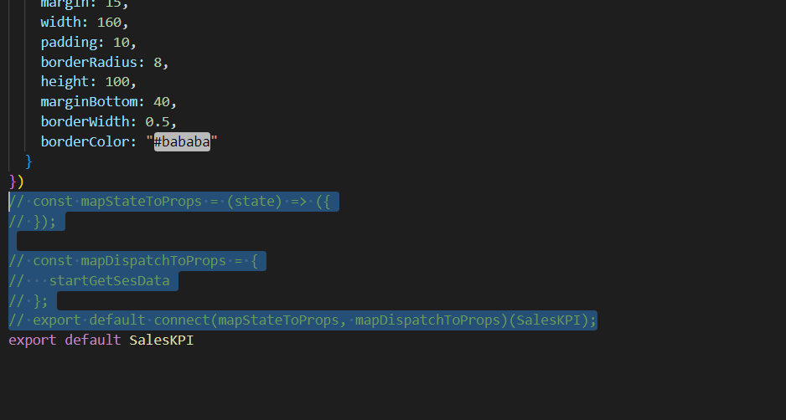
- Comment this selected code.
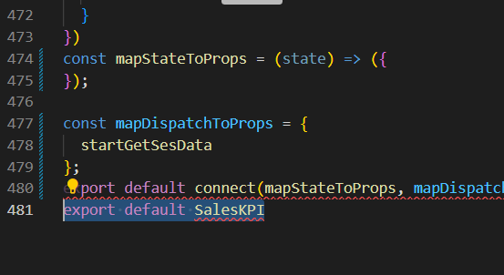

- Open crm bottomStack.js
- Add (paddingBottom :5) for tabBarStyle

